**DOCUMENTTATION OF DATA**

**ANAYLSIS**

Completed by:

**M . Muthu shanmuga vadivu**

**B. Bhavani**

**S. Kavitha**

**A. Maria Rosy**

PROJECT FLOW :

1. **INTRODUCTION:**
   1. **Overview**
   2. **Purpose**
2. **2 .Problem Definition & Design Thinking**

**2.1 Empathy Map**

**2.2 Ideation & Brainstorming Map**

1. **RESULT**
2. **ADVANTAGES & DISADVANTAGES**
3. **APPLICATIONS**
4. **CONCLUSION**
5. **FUTURE SCOPE**

***Unveiling Market Insights: Analysing***

***Spending Behaviour and Identifying***

***Opportunit Unveiling for Grouth.***

***INTRODUCTION:***

Wholesaling or distributing is the sale of goods or merchandise to retailer to industrial,

commercial, institutional or other professional businessman toother wholesalers (wholesale

businesses) and related subordinated services. In general, it is the sale of goods in bulk to

anyone, either a person or an organization, other than the end consumer of that

merchandise. Wholesaling is buying goods in bulk quantity, usually directly from the

manufacturer or source, at a discounted rate. The retailer then sells the goods to the end

consumer at a higher price making a profit.

The consumption and production of marketed food are spatially separated.

Production is primarily in rural areas while consumption is mainly in urban areas.

EMPATHY MAP:

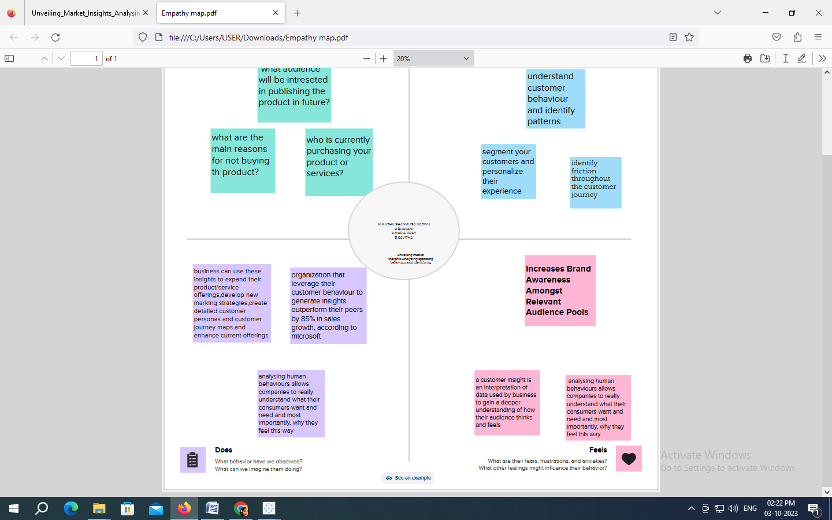

***IDEATION & BRAINSTORMING MAP:***

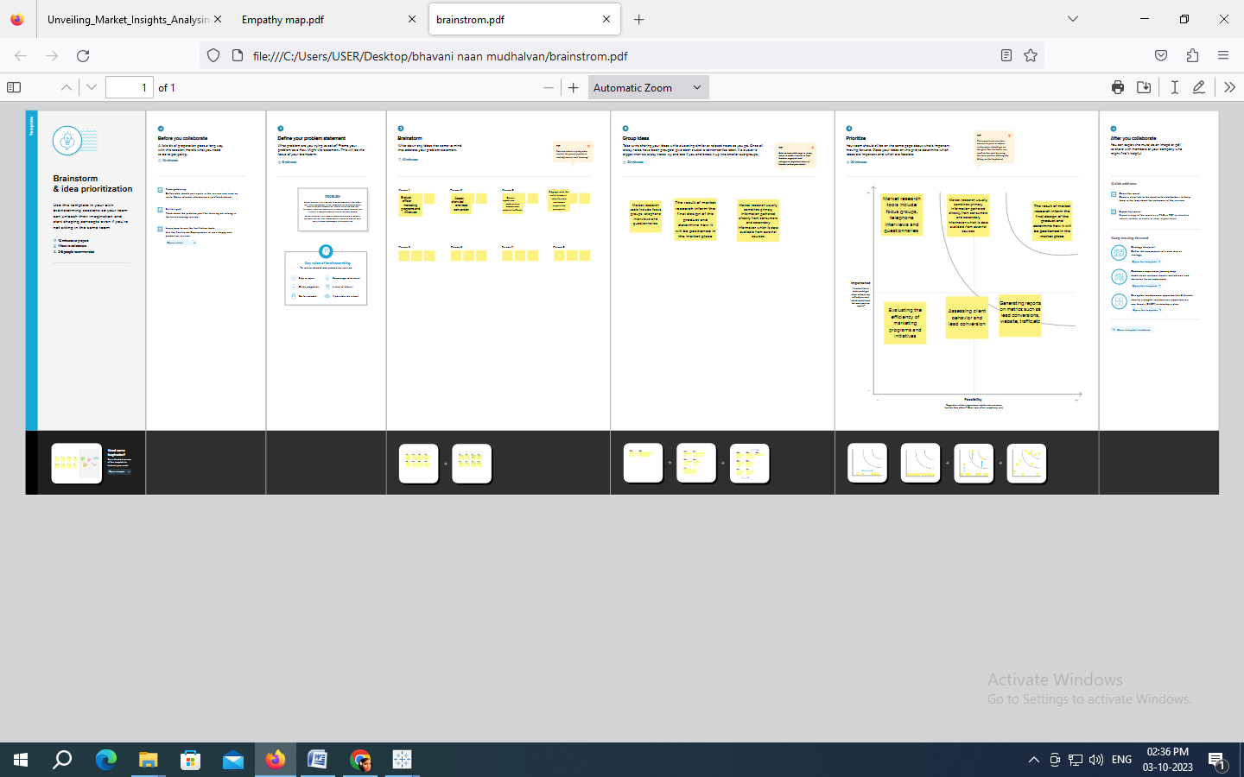

***Connection to the dataset:***

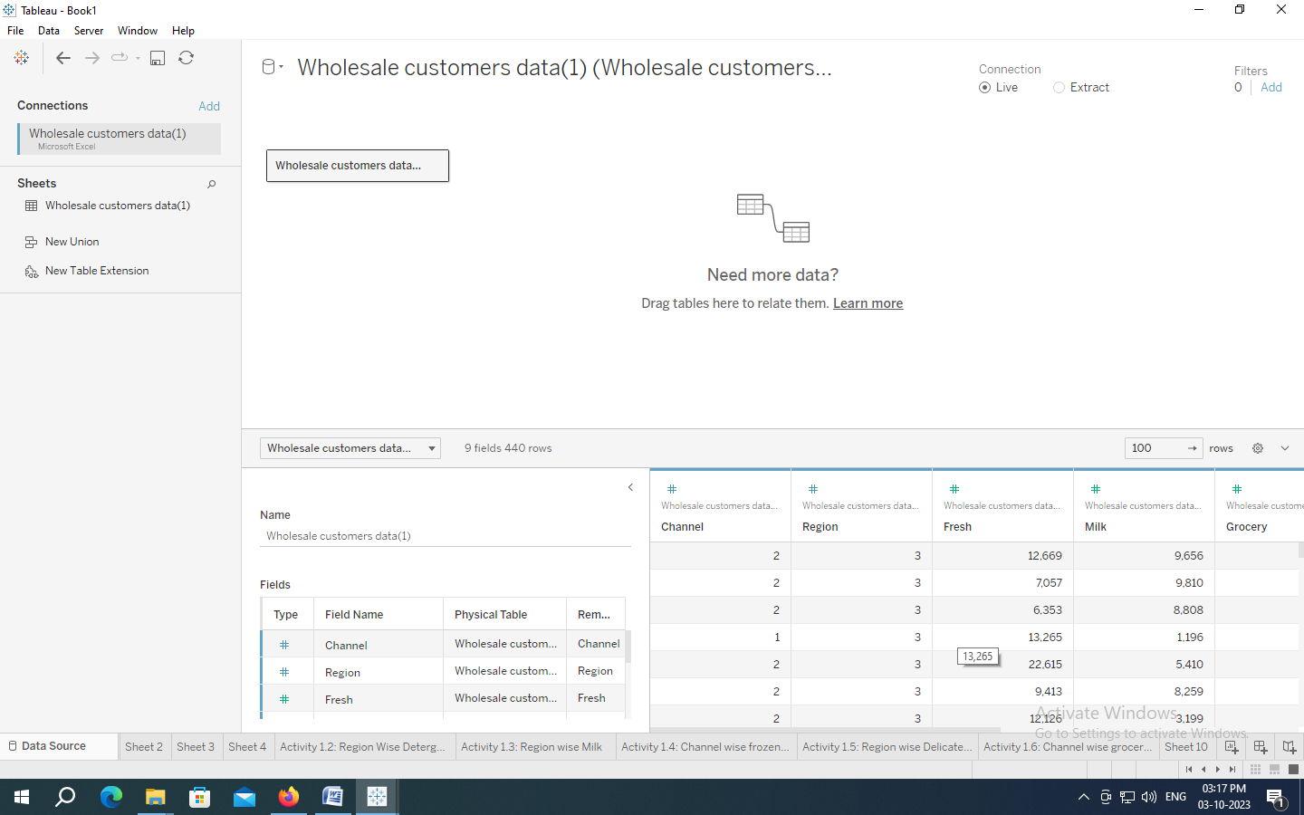

***RESULT:***

***Activity 1.1: KPI’s***

***MILK***

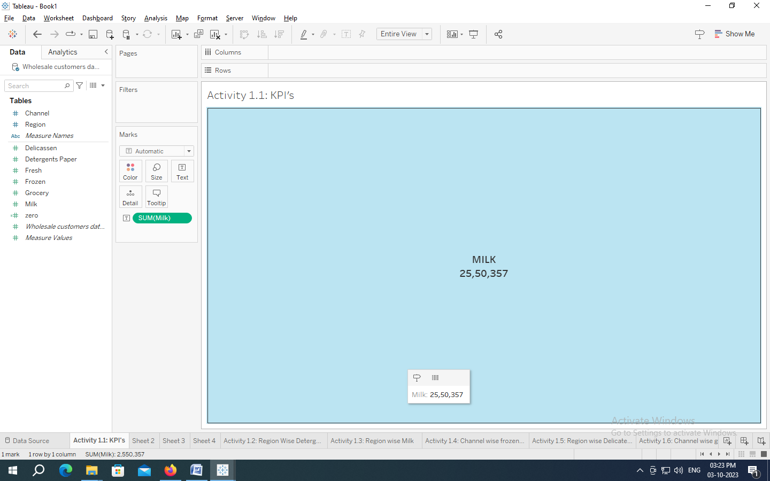

***GROCERY***

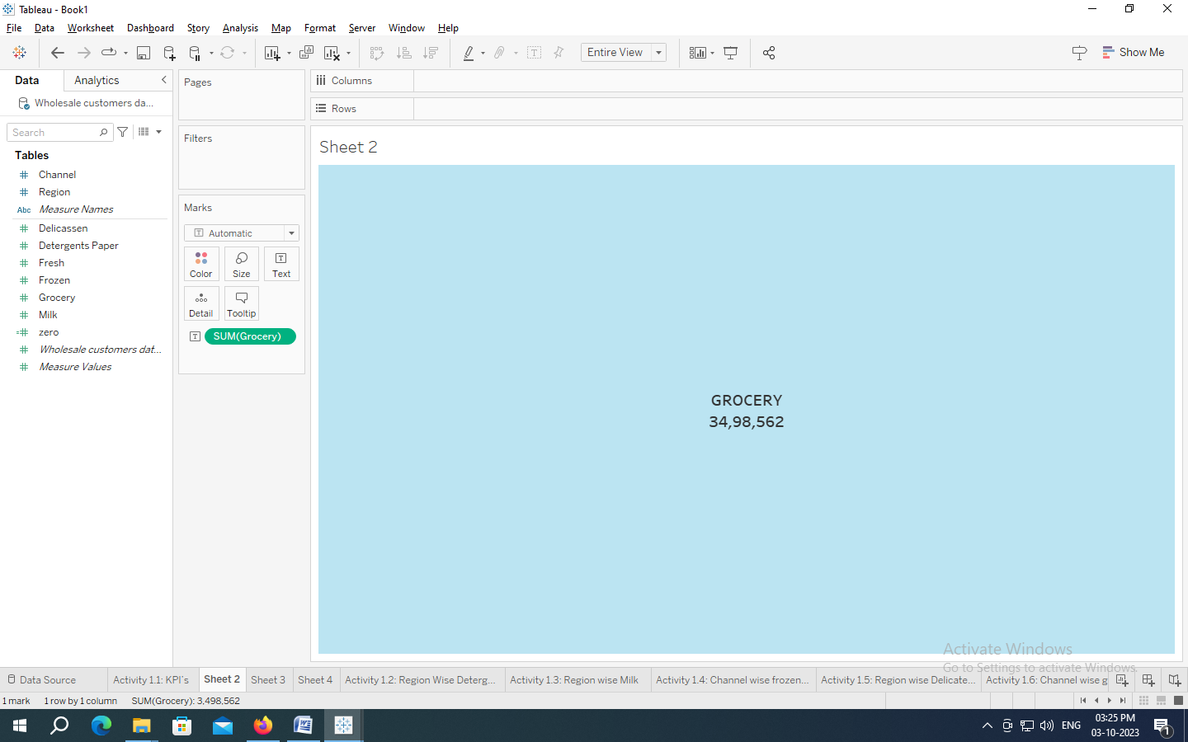

***FROZEN***

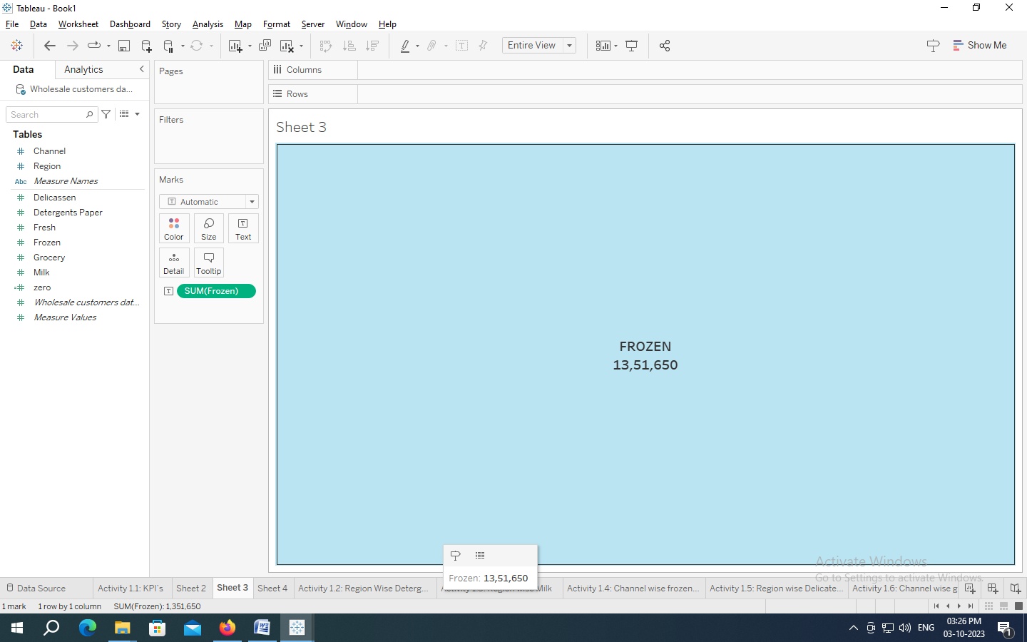

***FRESH***

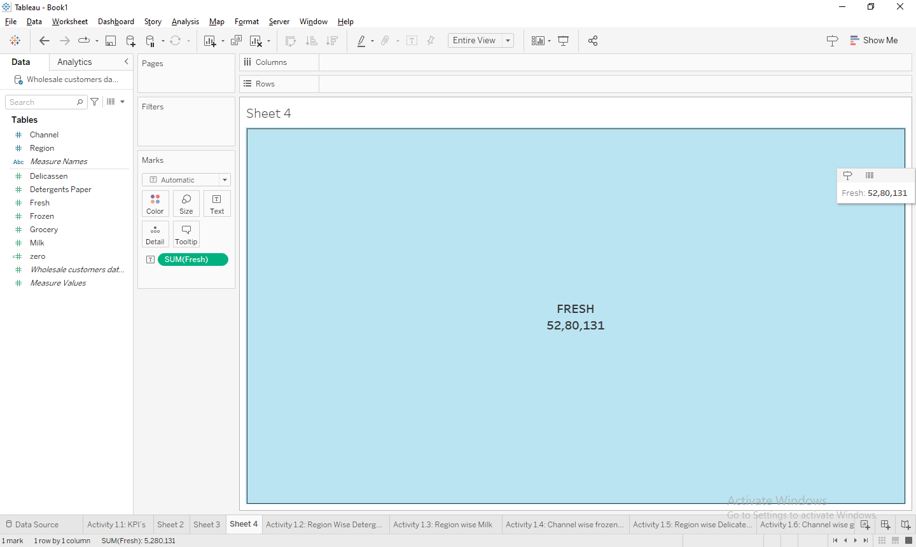

Activity 1.2: Region Wise Detergent paper and grocery

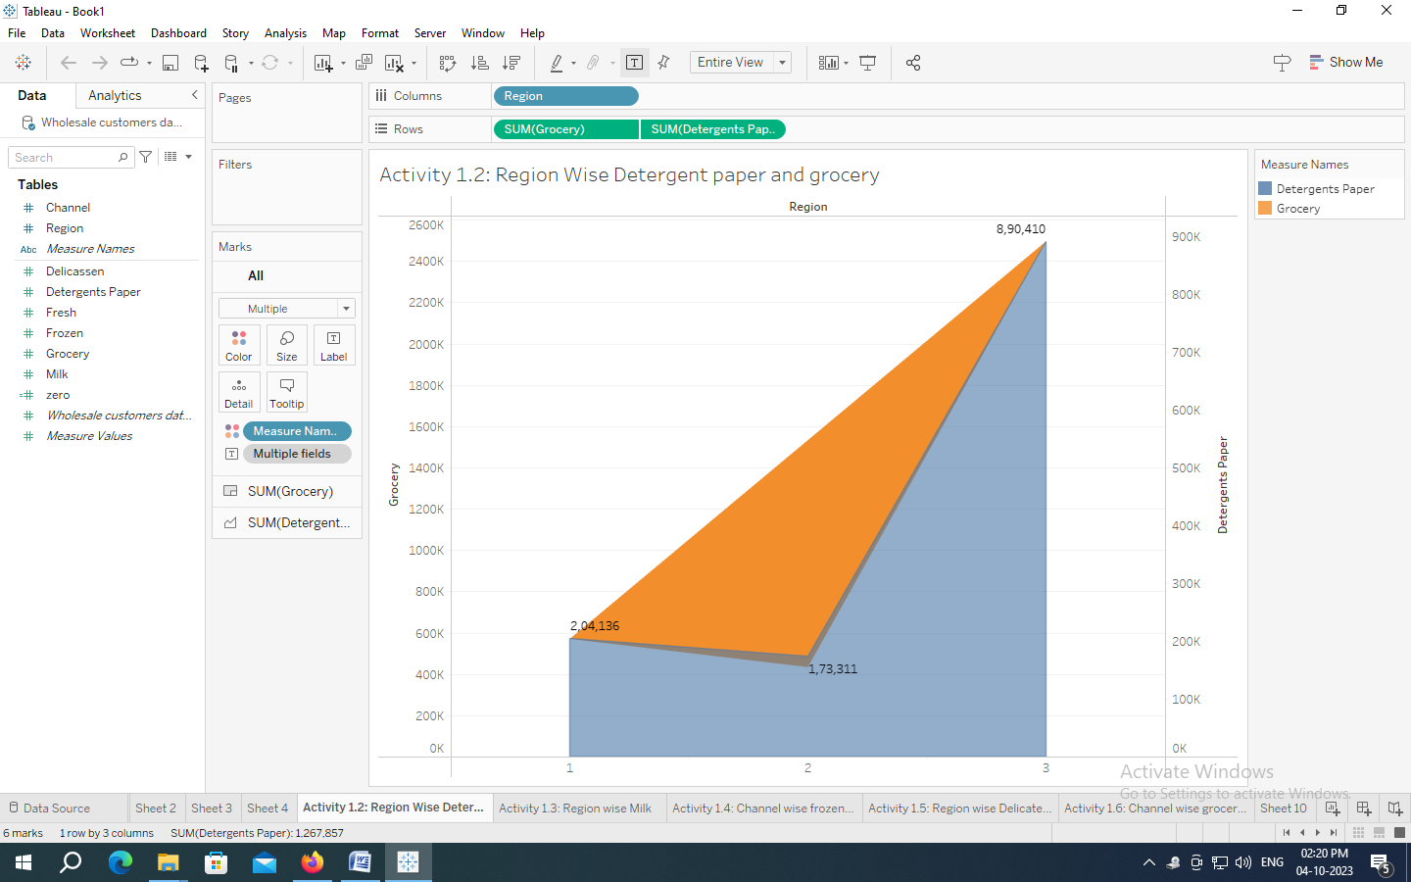

Activity 1.3: Region wise Milk

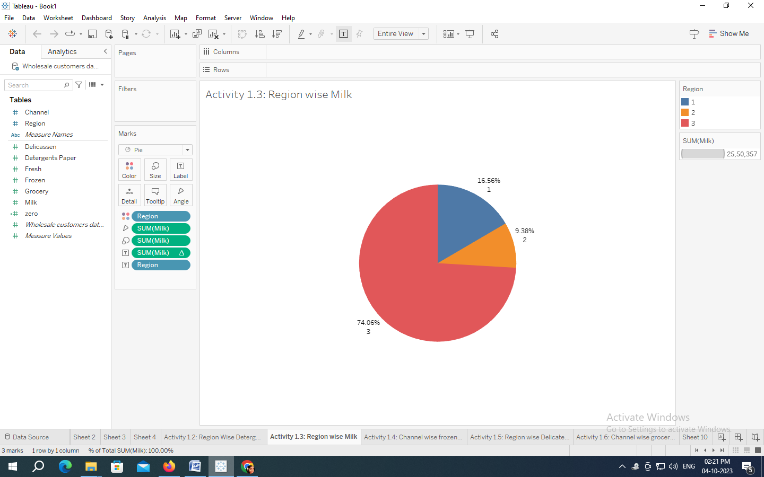

Activity 1.4: Channel wise frozen and Delicatessen

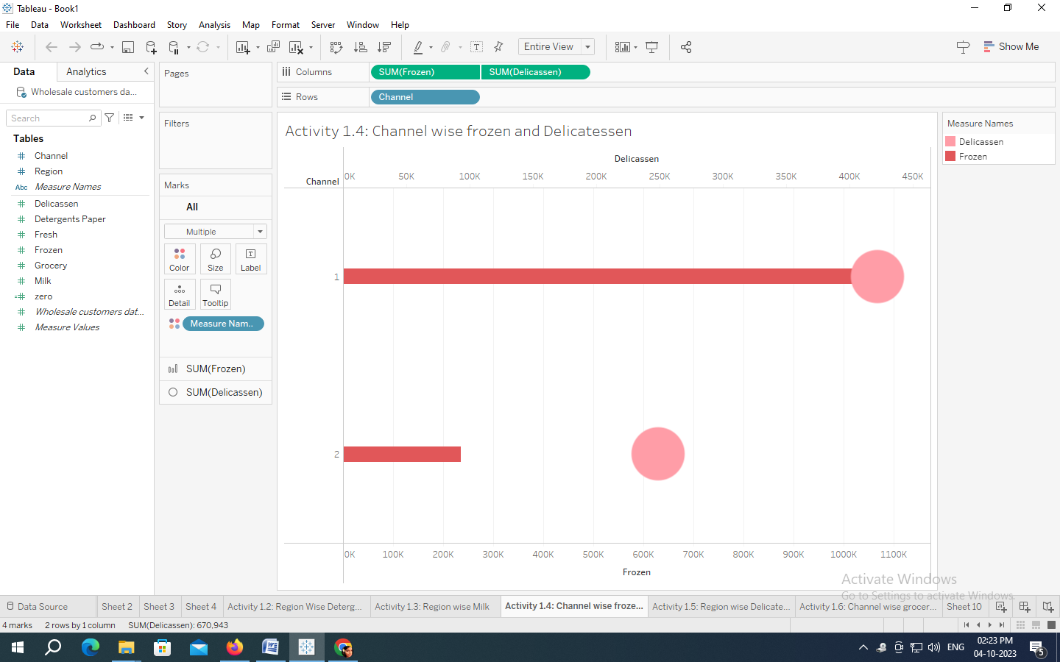

***Activity 1.5: Region wise Delicatessen and Detergent paper***

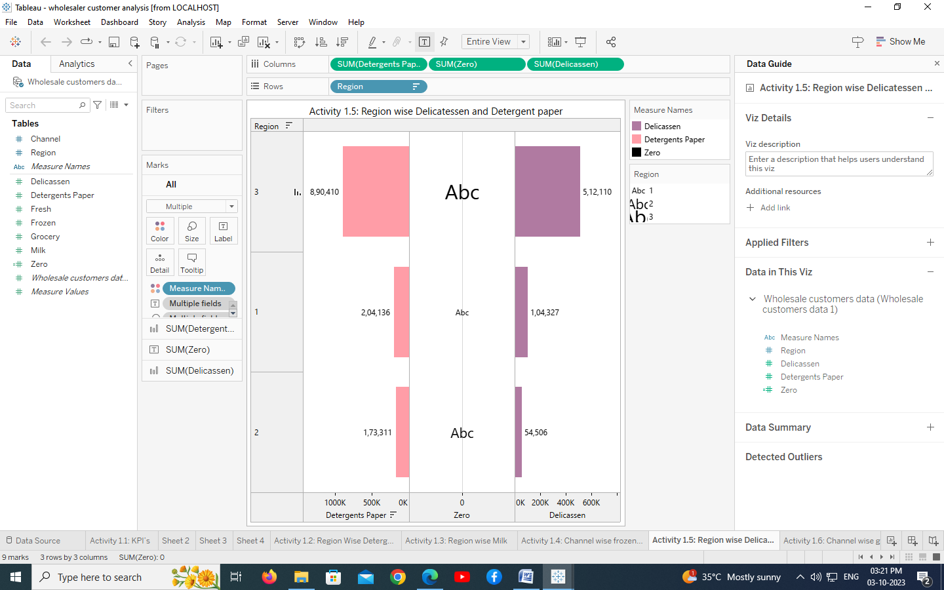

***Activity 1.6: Channel wise grocery and Detergent paper***

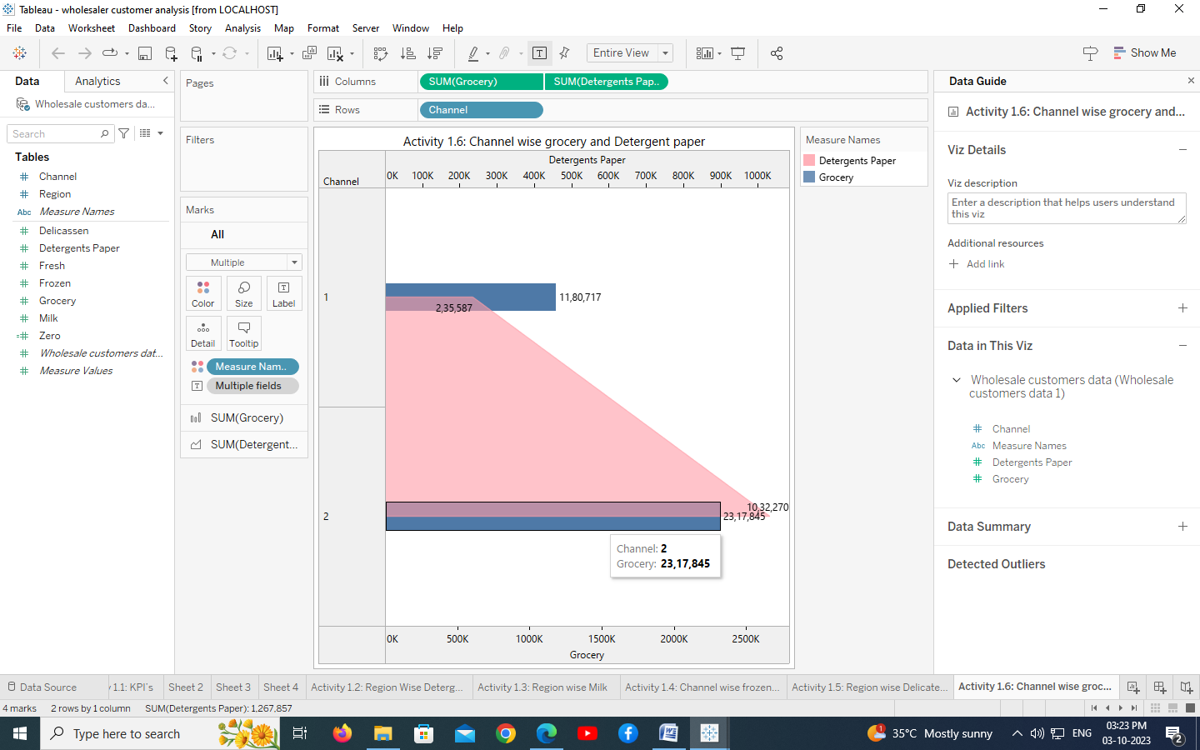

Activity 1.7

Region Wise Delicatessen

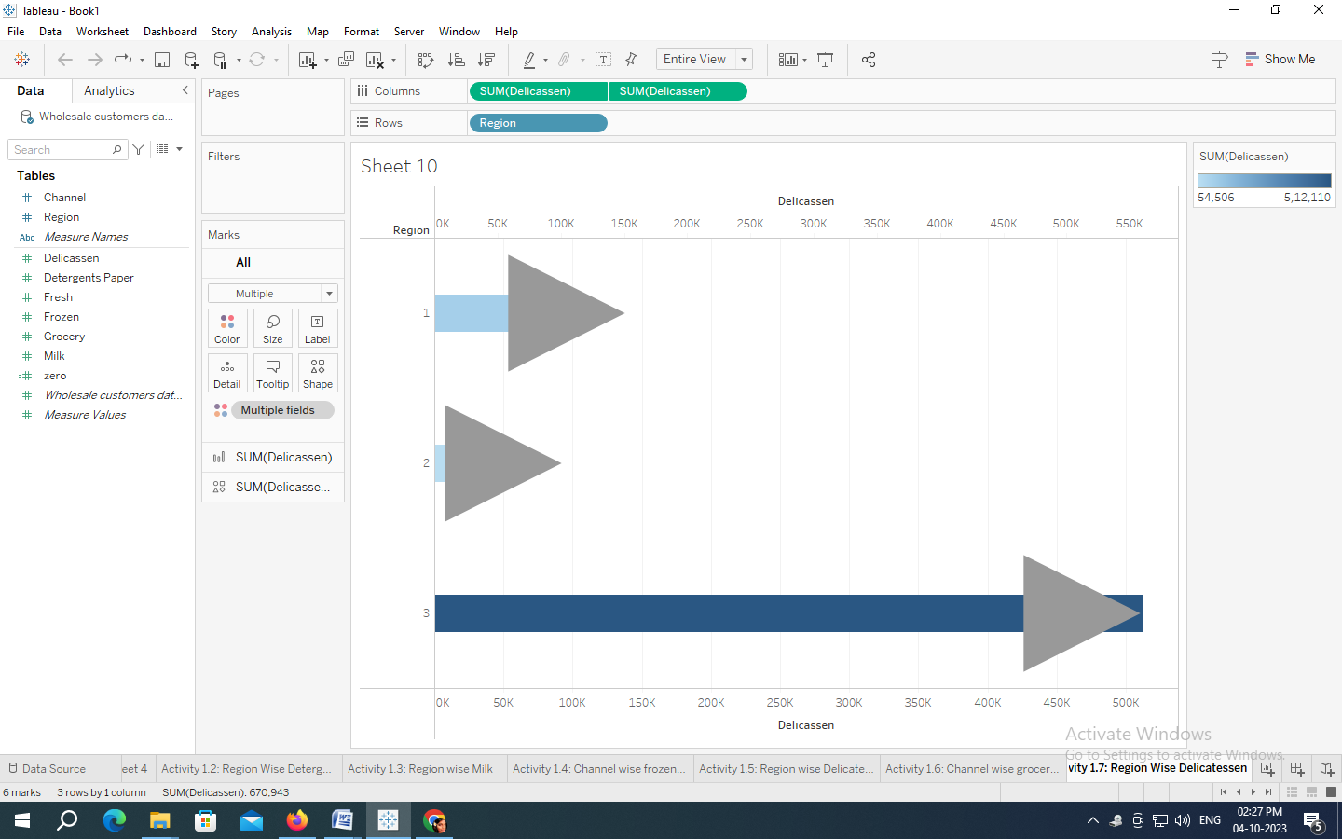

Dashboard:

Activity :1-

Responsive and Design of Dashboard

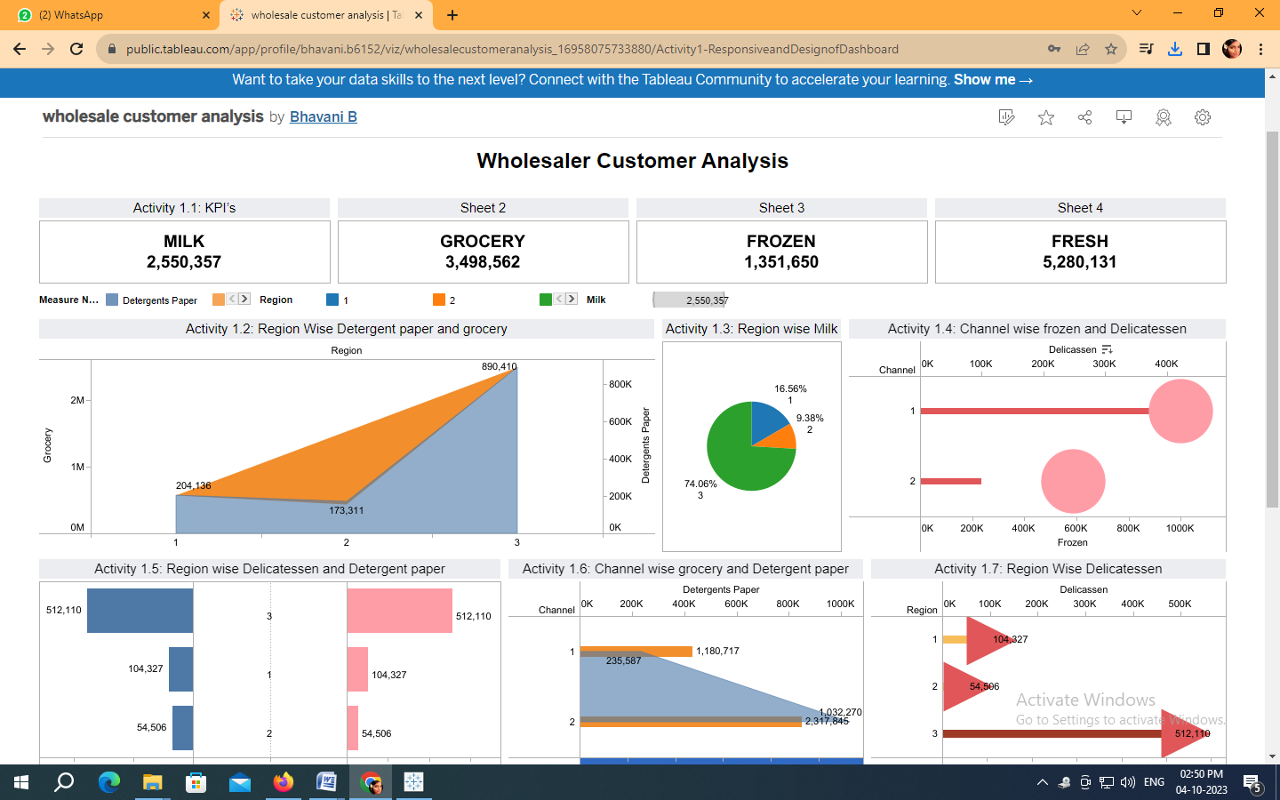

STORY:

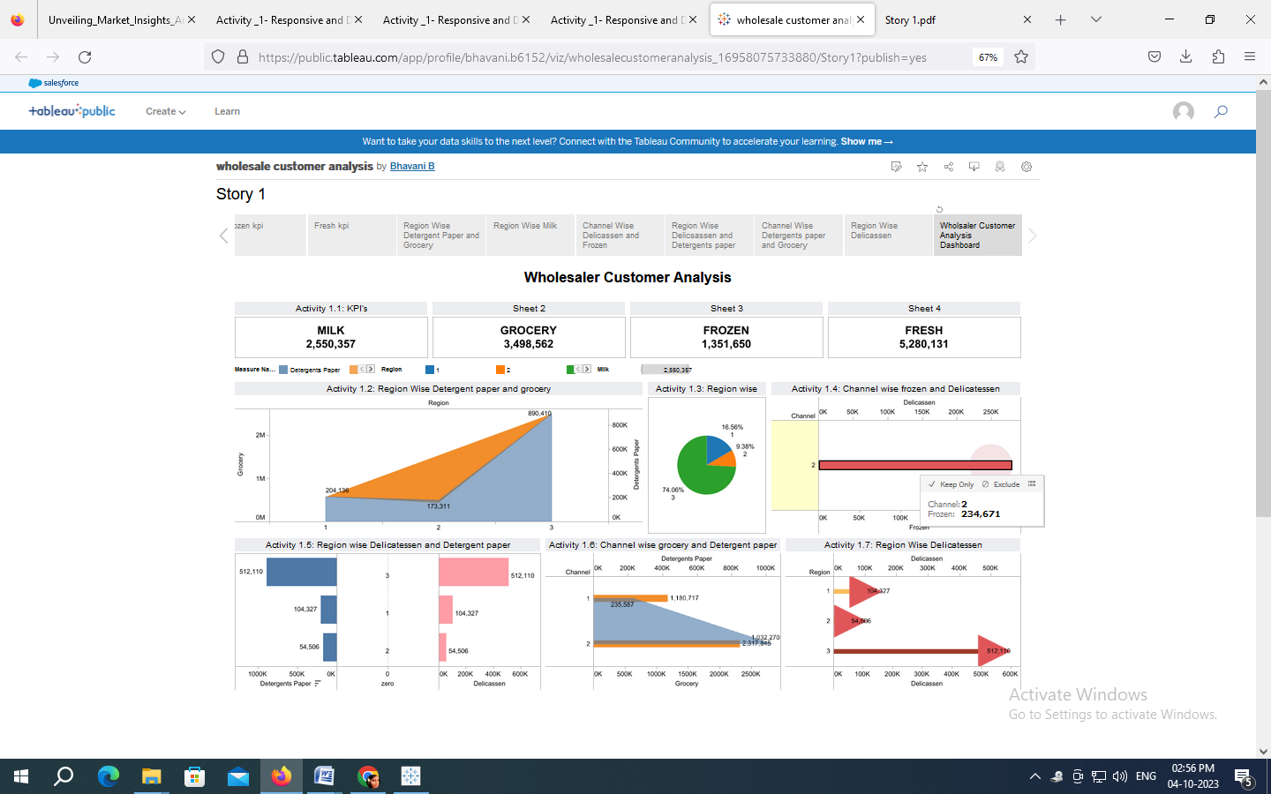

***ADVANTAGES AND DISADVANTAGES***

ADVANTAGES:

* Maintain a Customer-Centric Approach.
* Connect With Your Audience More Effectively.
* Identify Opportunities for Growth.
* Reduce Risks by Testing Concepts.
* Make More Informed Decisions.
* Compete More Effectively.
* Stay on Top of Trends.

DISADVANTAGE:

* Time-consuming and expensive compared to secondary research.
* Requires resources for survey design, data collection, and analysis.
* A limited sample size may not represent the entire target market.

APPLICATIONS:

* Pricing Research
* Product Research
* Concept Testing
* Positioning Research
* Customer Satisfaction Research
* Branding Research
* Advertising Research
* Market Segmentation
* Sales Analysis

Conclusion:

It shows analysis of marketing insights and the information about the data and shows the weak regions and channels and helps to improve the weakness and helps where to improve. By this the wholesaler makes plans to transport the goods and where to transport more goods. And what type of goods are selling more in which region and channel.

Future scope:

The scope of marketing research could cover the business problems relating to the followings

* Types of consumers that compromise present and potential markets.
* Buying habits and pattern of consumption.
* Size and location of different markets, not only in India but also overseas.

Course In-charge HOD Principal